**Moving average 3 months**

The moving average is typically used to display trends in line charts. Figure 12 includes the moving average of three months (Sales AVG 3M) and a year (Sales AVG 1Y).

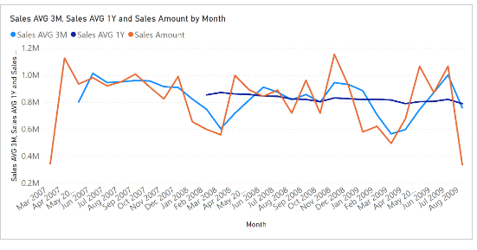The Sales AVG 3M measure computes the moving average over three months by iterating the last three months obtained in the Period3M variable:

Sales AVG 3M :=

VAR MonthsInRange = 3

VAR LastMonthRange =

    MAX ( 'Date'[Year Month Number] )

VAR FirstMonthRange =

    LastMonthRange - MonthsInRange + 1

VAR Period3M =

    FILTER (

        ALL ( 'Date'[Year Month Number] ),

        'Date'[Year Month Number] >= FirstMonthRange

            && 'Date'[Year Month Number] <= LastMonthRange

    )

VAR Result =

    IF (

        COUNTROWS ( Period3M ) >= MonthsInRange,

        CALCULATE (

            AVERAGEX ( Period3M, [Sales Amount] ),

            REMOVEFILTERS ( 'Date' )

        )

    )

RETURN

    Result